# Brainstorm

## Before you collaborate

###### A little bit of preparation goes a long way with this session. Here’s what you need to do to get going.

10 minutes

RASHIKA V

**1**

## Define your problem statement

###### What problem are you trying to solve? Frame your problem as a How Might We statement. This will be the focus of your brainstorm.

5 minutes

**2**

## Brainstorm

###### Write down any ideas that come to mind that address your problem statement.

10 minutes

**TIP**

You can select a sticky note and hit the pencil [switch to sketch] icon to start drawing!

**3**

## Group ideas

###### Take turns sharing your ideas while clustering similar or related notes as you go. Once all sticky notes have been grouped, give each cluster a sentence-like label. If a cluster is bigger than six sticky notes, try and see if you and break it up into smaller sub-groups.

20 minutes

**4**

## Prioritize

###### Your team should all be on the same page about what's important moving forward. Place your ideas on this grid to determine which ideas are important and which are feasible.

20 minutes

## After you collaborate

You can export the mural as an image or pdf to share with members of your company who might find it helpful.

**Quick add-ons**

# & idea prioritization

### Use this template in your own brainstorming sessions so your team can unleash their imagination and start shaping concepts even if you're not sitting in the same room.

1. Team gathering

Define who should participate in the session and send an invite. Share relevant information or pre-work ahead.

1. Set the goal

Think about the problem you'll be focusing on solving in the brainstorming session.

Learn how to use the facilitation tools

SANGAVI K SWETHA S SNEHA S

POOJALAKSHMI S

##### PROBLEM

An Advanced Smart crop protection system helps the farmers from preventing crops from damage by animals .The setup should be easy to handle in user friendly android based mobile device.

##### KALPANA

Using low cost software can increase productivity

Alarm can alert farmers

Notification will be sent to the user mobile

KARTHIGA

moisture level can be detected by mobile app

IOT

based Network

python based data to server

OVIYA

analyze data from IOT

SD Card Module is compatible with maximum micro contollers forums

CNN

Technology can be used

Using low cost software can increase productivity

Alarm can alert farmers

Sending information when needed

moisture level can be detected by mobile app

SD Card Module is compatible with maximum micro contollers forums

analyse data from IOT

device should feasibile

setup in water supply can improve agriculture

PIR sensor detects smoke flame etc and alert farmer

design a Device which could sustain climate changes

**TIP**

Add customizable tags to sticky notes to make it easier to find, browse, organize, and categorize important ideas as themes within your mural.

Ardino UNO helps to connect with devices

Use of low cost devices can increase

design a Device which could sustain climate changes

1. Share the mural

**Share a view link** to the mural with stakeholders to keep them in the loop about the outcomes of the session.

1. Export the mural

Export a copy of the mural as a PNG or PDF to attach to emails, include in slides, or save in your drive.

**10 minutes** to prepare

**1 hour** to collaborate

**2-8 people** recommended

**C**

Use the Facilitation Superpowers to run a happy and productive session.

[Open article](https://support.mural.co/en/articles/2113740-facilitation-superpowers)

#### Key rules of brainstorming

To run an smooth and productive session

setup LCD Display for the Status and Output

KARTHIGA

setup in water supply can improve agriculture

Solar panel

can be used so that device can be charged

Electric fence can be avoided

Sending information when needed

SANGEETHA

Ardino UNO helps to connect with devices

making book for references

PIR sensor detects smoke flame etc and alert farmer

Flame sensor is most sensitive can be used

For Irrigation water supply can be Controlled

setup LCD Display for the Status and Output

python based data to server

For Irrigation water supply can be Controlled

using lr

sensors to Detect animals

Ardino UNO helps to connect with devices

### setup LCD

Display for the Status and Output

Flame sensor

is most sensitive can be used

PIR sensor detects smoke flame etc and alert farmer

in

productivity

#### Keep moving forward

Strategy blueprint

Define the components of a new idea or strategy.

[Open the template](https://app.mural.co/template/e95f612a-f72a-4772-bc48-545aaa04e0c9/984865a6-0a96-4472-a48d-47639307b3ca)

**Customer experience journey map**

Stay in topic. Defer judgment.

Encourage wild ideas. Listen to others.

device should feasible

photocopies will be stored in application

#### Importance

If each of these

###### photocopies will be stored in application

Sending

### ALARM Can

Alert the Farmer

Understand customer needs, motivations, and obstacles for an experience.

[Open the template](https://app.mural.co/template/b7114010-3a67-4d63-a51d-6f2cedc9633f/c1b465ab-57af-4624-8faf-ebb312edc0eb)

Go for volume. If possible, be visual.

Scarecrow can be avoided

using lr sensors to Detect animals

human also cannot enter without permission

design a Device which could sustain climate changes

tasks could get

done without any difficulty or cost, which would have the most positive impact?

###### information when needed

Strengths, weaknesses, opportunities & threats

Identify strengths, weaknesses, opportunities, and threats (SWOT) to develop a plan.

[Open the template](https://app.mural.co/template/6a062671-89ee-4b76-9409-2603d8b098be/ca270343-1d54-4952-9d8c-fbc303ffd0f2)

**TIP**

Participants can use their cursors to point at where sticky notes should go on the grid. The facilitator can confirm the spot by using the laser pointer holding the **H key** on the keyboard.

### Movement of the animals can be detected using motion Sensor

[**Share template feedback**](https://muralco.typeform.com/to/CiqaHVat?typeform-source=app.mural.co)

[**Share template feedback**](https://muralco.typeform.com/to/CiqaHVat?typeform-source=app.mural.co)

#### Feasibility

Regardless of their importance, which tasks are more feasible than others? (Cost, time, effort, complexity, etc.)

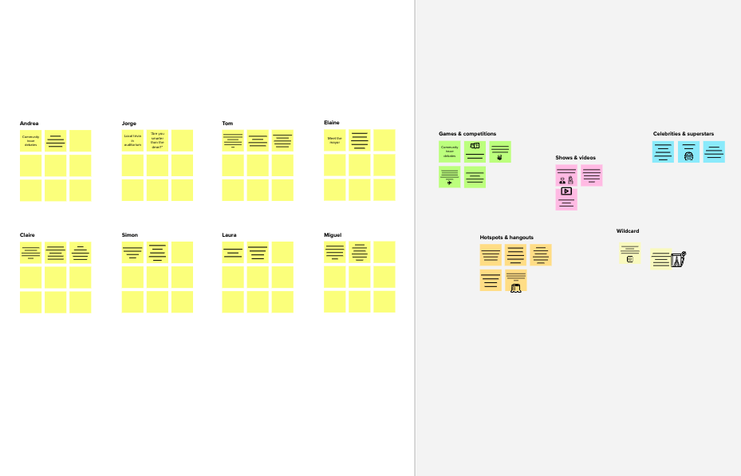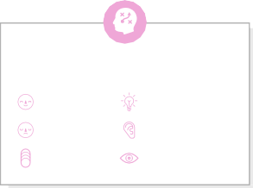

**Template**

##### Need some inspiration?

See a finished version of this template to kickstart your work.

[**Open example**](https://app.mural.co/template/e5a93b7b-49f2-48c9-afd7-a635d860eba6/93f1b98d-b2d2-4695-8e85-7e9c0d2fd9b9)